

*Data Validation:*

*Sales*

**Table of Contents**

Data Validation 3

Why 3

Roles & Responsibilities 3

Bill-Tos 4

Why 4

What to check 4

How 6

Roles & Responsibilities 6

Ship-Tos 7

Why 7

What to check 7

How 9

Roles & Responsibilities 9

Sales Orders 10

Why 10

What to check 10

How 19

Roles & Responsibilities 19

Data Validation – Full Circle 20

Data Imported 20

Data Validated 20

Data Processed 20

Postings 20

Reports 20

Why Data Validation Is Critical 21

Lower Risks 21

Go Live Duration 21

Customer Service 21

Procurement 21

Reporting 21

Success 21

# Data Validation

## Why

Why is data validation critical to any ERP implementation? Data is one of the most important parts of any implementation. The old saying of “Garbage In / Garbage Out” can be applied here. If we load bad or poor-quality data, the outputs of that data will be bad or have poor-quality. The more data validation that is done during implementation, the better the overall outputs will be. Taking ownership of the data begins with data validation. It will also provide a smoother transition and reduce or eliminate issues at Go Live. Data and data validation are key to a successful Go Live.

## Roles & Responsibilities

There are several roles that are involved with data validation. It’s a team effort. The Data Specialists, the Product Specialists, Subject Matter Experts (SMEs) and End Users have critical roles to play in data validation.

The Data Specialist’s role in validation is the same for every section so we will discuss here. It begins with the load file. Along with the Product Specialist (PS), they will review the file and determine where the data will reside in DEACOM. The Data Specialist’s responsibility is to confirm record counts and validate the information in the file loaded to the fields mapped in the data profile. This is the first level of data validation. The data profile will be modified to fix any issues found during this validation. However, the file may be missing key information that the data specialist does not know exists or during implementation new data is identified that is required to support a new process.

Data Specialists can also provide spreadsheets that can be used to easily filter or sort and review many records at one time. **Note: these spreadsheets are for validation only and will not be used to update every field on the spreadsheet. However, the spreadsheets can be used to update a single field.** The root cause of any data issue will be researched, and the data profiles updated so the data can be updated, and new records will come in with the proper changes and existing records will be updated.

The Product Specialist’s role in validation is to review the data loaded for every section and help discover, during Standard Operating Procedures (SOPs) validation, if we are missing any key data, while at the same time validating these processes using the imported data. This data will also be used in Mock Go Live and Conference Room Pilots (CRPs).

# Bill-Tos

## Why

Customers are key to any company’s success. Happy customers tell other people about the company’s products and services. It is important that the implementation cutover has minimal impact on that relationship and has little to no impact on standard processes. That is why it is important that imported data for the Bill-Tos are correct. Acknowledgements and invoices will make it to the correct place, and the cash flow is not affected. Implementations can span months or years and the data is constantly changing. It is important to validate that information and take ownership to ensure it is maintained.

## What to check

The best place to start checking is the basic information. For example, Name, Address, Email, Fax, Contact and Phone information. Other key fields including AR account, Terms, Credit Limits, PO Required and Sales Reps are also important. Each implementation is different, so it is important to check any other special setup that was configured. e.g. User Defined Fields (UDFs) or system flags. The data process is scientific and will load the data to the same fields every time.

Where to begin?

* Customers with largest sales volume.
* Customers that have only one Ship-To.
* Customers with multiple Ship-Tos.
* Customers from different industries.
* Customers from different territories.
* If you are bringing in inactive customers for historical data, check a few of those too.
* In DEACOM, go to **Sales > Customers**
* **Report Type**: Bill to Company
* **Bill to display**: All (shows both active and inactive)
  + Click on **View**

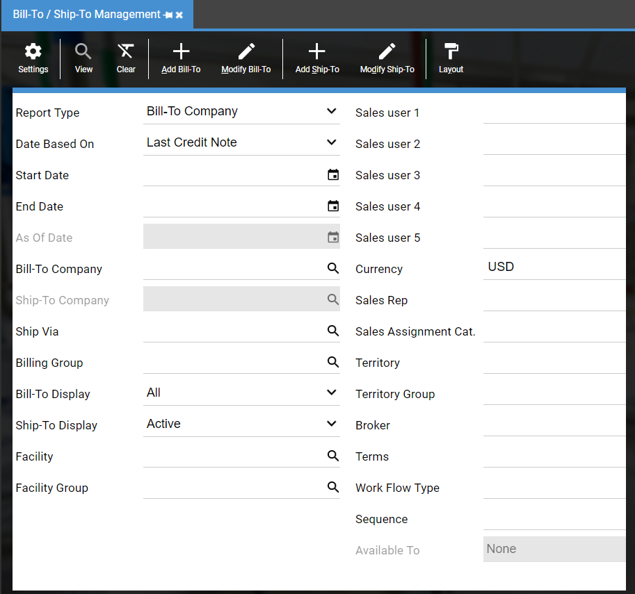

* To see your legacy Bill-To ID, add bi_custid to the grid

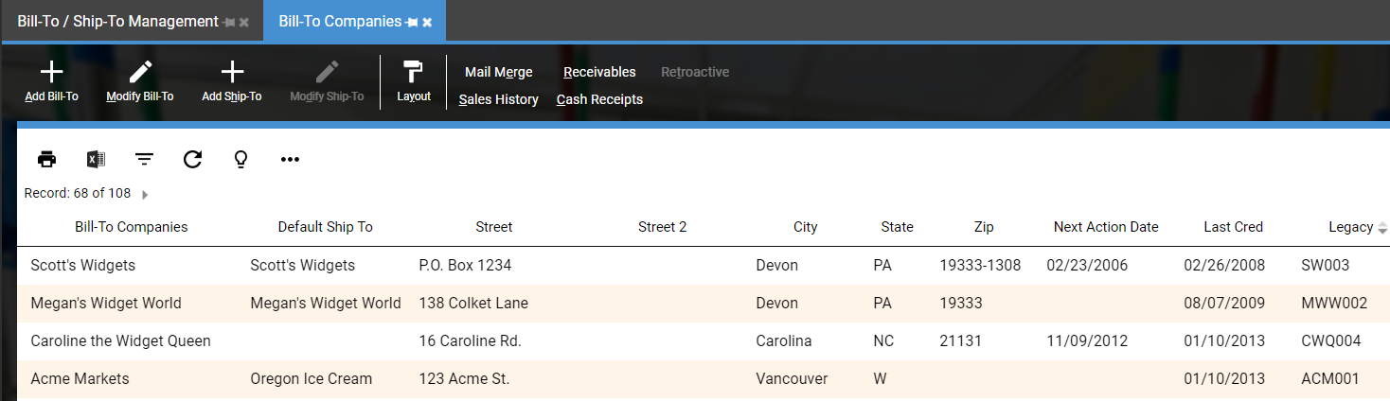

* Compare to customers from legacy system

**General tab**

Validate Bill to Company, Contact, Address lines, Email, Fax and Phone information

Validate AR account

Validate Active checkbox

**Ship-To Defaults tab**

Validate Search Fields

Validate Ship Via and Freight Type

**Credit tab**

Validate Terms

Validate Credit Limit

**Sales Assignments tab**

Validate Sales reps

**Ship-To Companies tab**

Validate Ship-To Companies

**Other**

Confirm total number of Bill-To’s match the expected number

Validate other key fields

## How

The best way is to bring the customer up in the legacy system and bring the customer up in DEACOM. Carefully compare the data for each field. If you find information is missing or in the wrong field, contact the data specialist and they will determine why this is happening.

## Roles & Responsibilities

Typically, Subject Matter Experts, Customer Service and/or Sales employees have the responsibility to validate the data. The Accounting team should confirm the proper AR accounts are being used. They use the data every day and can easily spot if key data is missing.

# Ship-Tos

## Why

Ship-To data is crucial to the order process. It contains the necessary shipping information for Sales Orders (e.g. name, address, contact, phone and EDI data). Ship-To records also hold valuable default information that will be transferred to the Sales Order when it is entered (e.g. Ship via, Search fields and Sales Assignments). It is crucial for logistical purposes that the shipping information is validated so customers receive their orders at the correct address. If this information is incorrect, shipments will go to the wrong address and sales reports will have bad-quality data.

## What to check

The best place to start checking is the basic information. For example, Name, Address, Email, Fax, Contact, and Phone. Other key fields transferred to orders include default Ship via, Freight Type and Search fields.

Where to begin?

* Customers with the largest sales volume. Check that all their Ship-Tos exist.
* Confirm the Ship-Tos are linked to the proper Bill-Tos.
* Run reports by Search fields to confirm Ship-Tos are correctly set.
* If you are bringing in inactive Ship-Tos for historical data, check a few of those too.
* If using EDI, check that the correct information loaded.
* In DEACOM, go to **Sales > Customers**
* **Report Type**: Ship to Company
* **Display**: All
  + Click on **View**

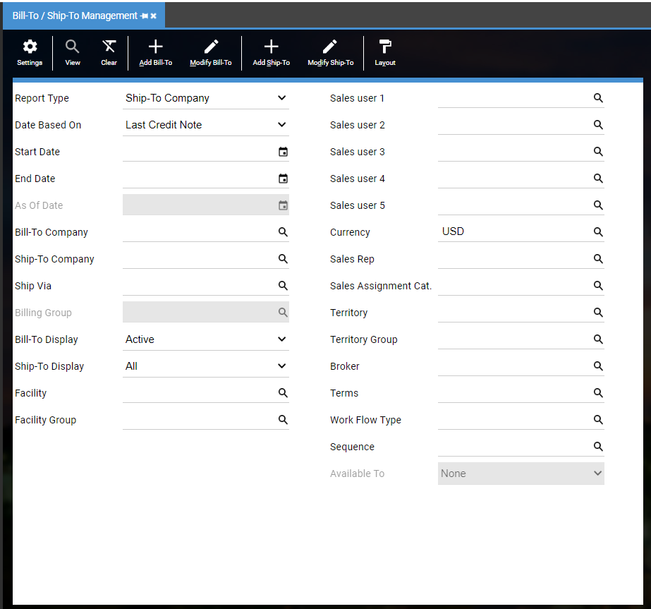

* To see your legacy Ship-To ID, add sh_custid to the grid

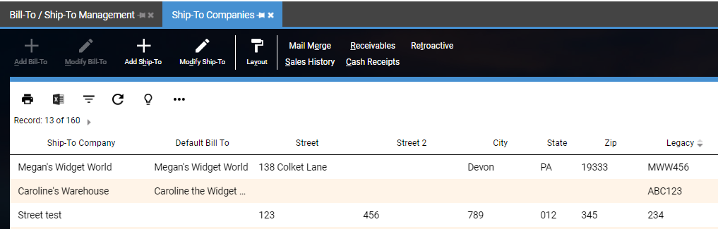

* Compare to customers from legacy system

**General tab**

Validate Ship to Company, Contact, Address lines, Email, Fax and Phone information

Validate Active checkbox

**Order Defaults tab**

Validate Search Fields

Validate Ship Via and Freight Type

**Credit tab**

Validate Terms

**Sales Reps tab**

Validate Sales reps

**Bill-To Companies tab**

Validate Bill-To Companies

**Other**

Confirm total number of Ship-To’s match the expected number

Validate other key fields

## How

The best way is to bring the Ship-To up in the legacy system and bring the Ship-To up in DEACOM. Carefully compare the data for each field. If you find information is missing or in the wrong field, contact the data specialist and they will determine why this is happening.

## Roles & Responsibilities

Typically, Subject Matter Experts, Customer Service and/or Sales employees have the responsibility to validate the data. They use the data every day and can easily spot if key data is missing.

# Sales Orders

## Why

Sales Orders in DEACOM are used to define the items or services that will be sold to customers along with the appropriate Payment Terms, Delivery Dates, Quantities, Shipping Terms, and all other obligations and conditions. It is vital to the ensure open sales orders have the correct information so shipments to your customers continue without delay. It is also important that historical sales orders are validated to ensure reliable reporting.

## What to check

The best place to start checking is the basic information. Confirm the legacy order number, the Bill-To and Ship-To, AR account, Items, Terms, Ship via, Order Dates, Unit Price, and total order amount. Be sure to confirm search fields, order notes and UDFs if applicable.

Where to begin?

* Compare open order report from legacy system to open order report from DEACOM. It is important to validate early as open orders will change after load files are prepared.
* Compare historical orders/invoices report from legacy system to historical orders/invoices report from DEACOM.
* Working from a static test copy of your legacy system is the best as the data is not changing.

You can search by your legacy system SO Number, Invoice Number or AR Reference number by entering that number into the “Order description” field in Sales Order Management.

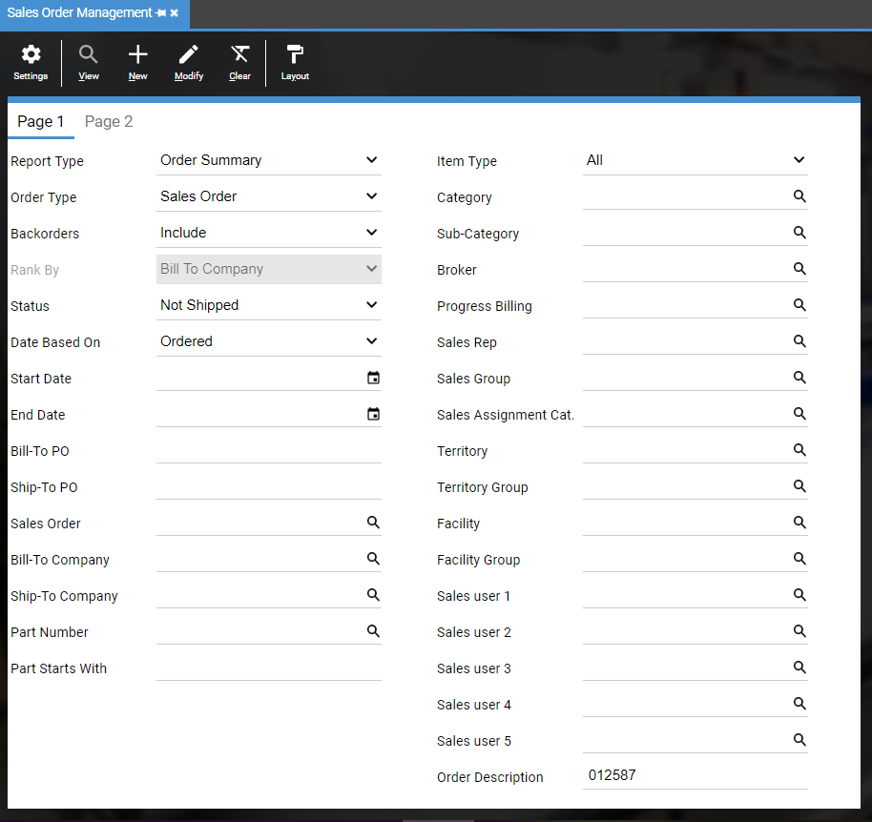

**Validation of SO – Status: Not Shipped**

* In DEACOM, go to **Sales > Order Reporting**
* **Report Type**: Order Summary
* **Status**: Not Shipped
* If applicable, run reports by facility
* Click on **View**

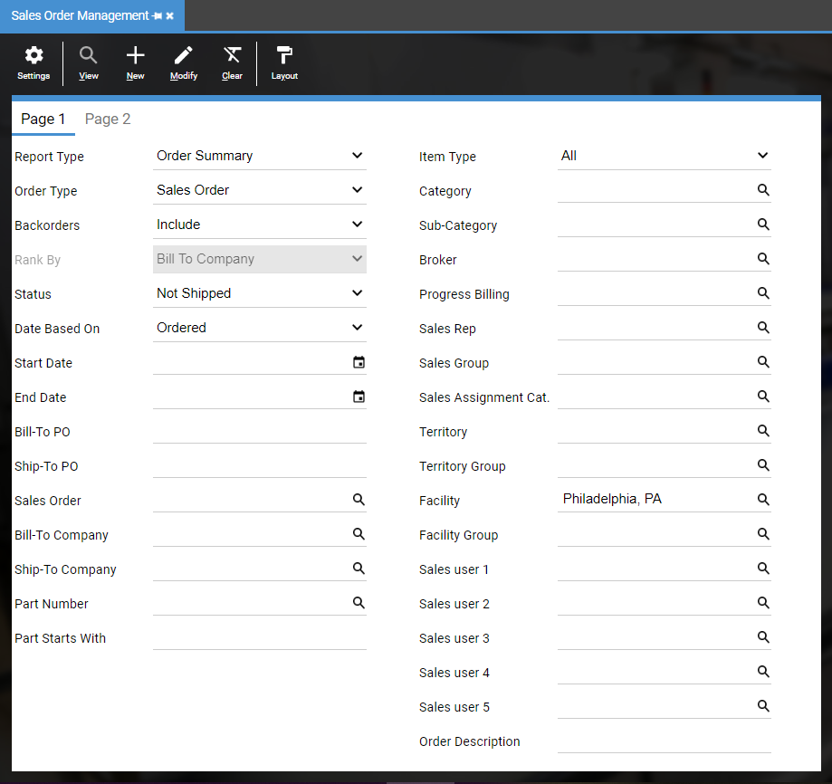

* To see your legacy Sales Order number, add to_descrip to the grid

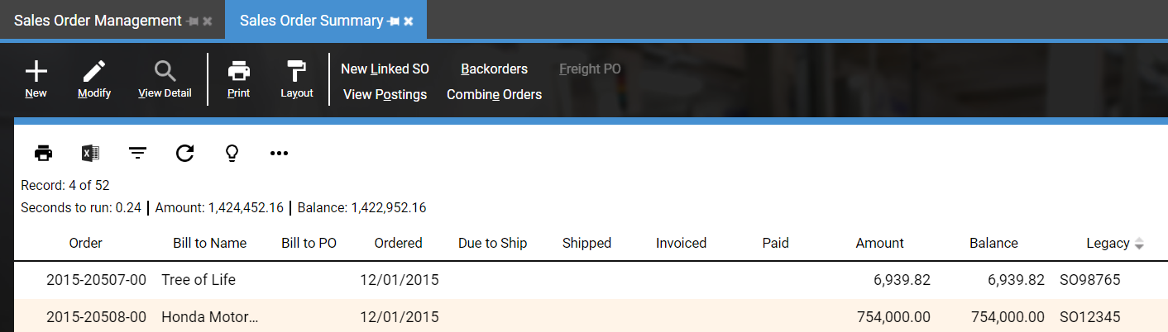

* Compare to open orders report from legacy system

Confirm total number of orders match

Confirm total Amount and Balance dollars match

Confirm individual orders lines for accuracy

* Prior to Actual Go Live, test daily processes using imported data. This typically occurs after a Mock Go Live and/or during a Conference Room Pilot (CRP).

Ship and invoice imported open Sales Orders

**Validation of SO – Status: Invoiced**

* In DEACOM, go to **Sales > Order Reporting**
* **Report Type**: Order Summary
* **Status**: Invoiced
* If applicable, run reports by facility
* Click on **View**

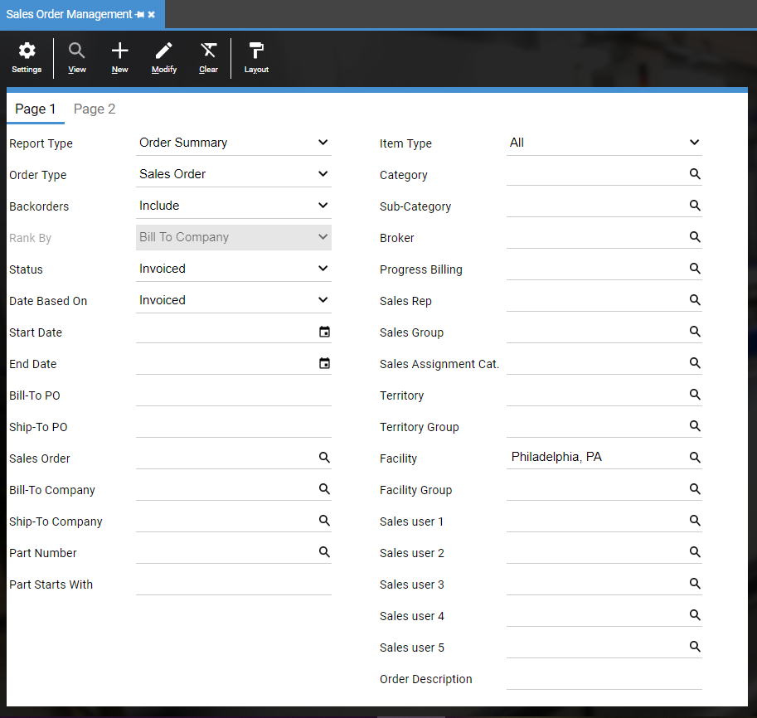

* Filter by the first 4 digits of the Order Number if needed (Invoiced Report includes AR Invoices, which typically start with 2000-, and Open AR by default)
* To see your legacy Invoice number, add to_descrip to the grid
* Compare to AR Invoice report from legacy system

Confirm total Amount (not Balance) dollars match

Confirm individual orders lines for accuracy

Confirm Totals Year by Year. Record total Amount below.

SO AR Invoices

|  |  |  |  |
| --- | --- | --- | --- |
| **Company** | **Year** | **Legacy System $** | **DEACOM $ Amount** |
| Company1 |  |  |  |

|  |  |  |  |
| --- | --- | --- | --- |
| **Company** | **Year** | **Legacy System $** | **DEACOM $ Amount** |
| Company2 |  |  |  |

* In DEACOM, go to **Sales > Order Reporting**
* **Report Type**: Order Detail
* **Status**: Invoiced
* If applicable, run reports by facility
* Click on **View**

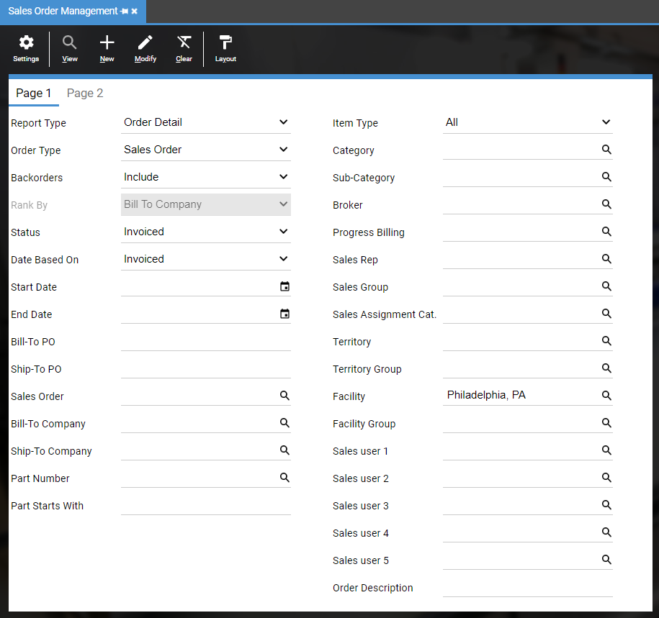

* Filter by the first 4 digits of the Order Number if needed (Invoiced Report includes AR Invoices, which typically start with 2000-, and Open AR by default)
* Compare to AR Invoice report from legacy system

Confirm total Amount (not Balance) dollars match

Confirm individual orders lines for accuracy

* Prior to Actual Go Live, test daily processes using imported data. This typically occurs after a Mock Go Live and/or during a Conference Room Pilot (CRP).

Receive payments on invoiced Sales Orders

Confirm Taxes (if imported with AR Invoices):

* In DEACOM, go to **Accounting > Accounting Reporting**
* **Report Type**: Sales Tax
* **Date Range:** Date of oldest Invoiced Sales Order to date data was pulled (does not pull negative taxes)
* If applicable, run reports by facility
* Click on **View**

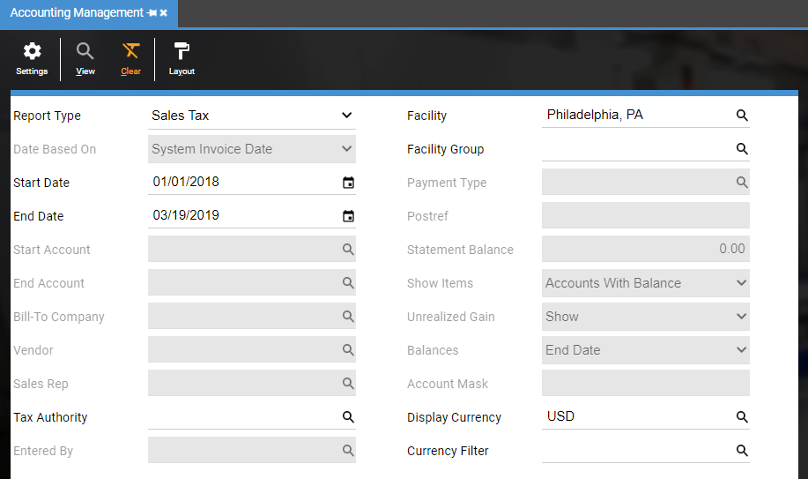

* Compare to AR Invoice tax report from legacy system

Confirm total dollars match

Confirm individual orders tax lines for accuracy

**Validation of AR – Set Balances**

* In DEACOM, go to **Sales > Order Reporting**
* **Report Type**: Order Summary
* **Status**: Invoiced not paid
* If applicable, run reports by facility
* Click on **View**

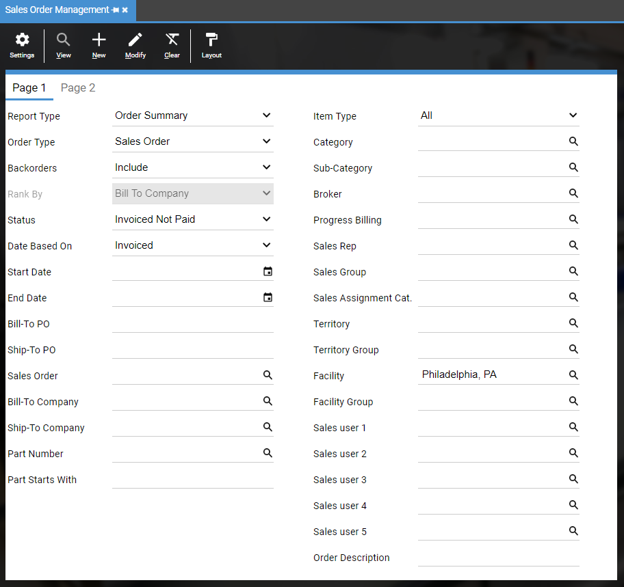

* To see your legacy Invoice number, add to_descrip to the grid
* Compare to AR Aging report from legacy system

Confirm and record total Balance (found in the report title bar; not Amount)

Confirm individual orders lines for accuracy

* Use Subtotal button to summarize by Company
  + - Click on **More** button
    - Select **Subtotals**
    - Click on **Add**
    - Select **Bill To Name**
    - **Save** and Close
    - Click the **Summary** button

Confirm company Balances (not Amount)

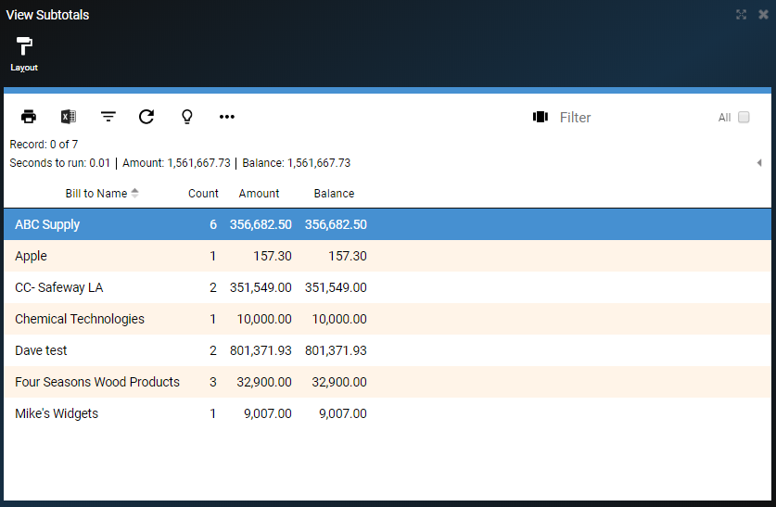

Total Balance above should match the following reports:

* In DEACOM, go to **Accounting > Accounting Reporting**
* **Report Type**: Trial Balance
* **Date Range**: First Day of Current Fiscal Year to Go Live Date
* If applicable, run reports by facility, using the Account mask
  + (e.g. ??????-01-??-?? where the second segment is the facility.)
* Click on **View**

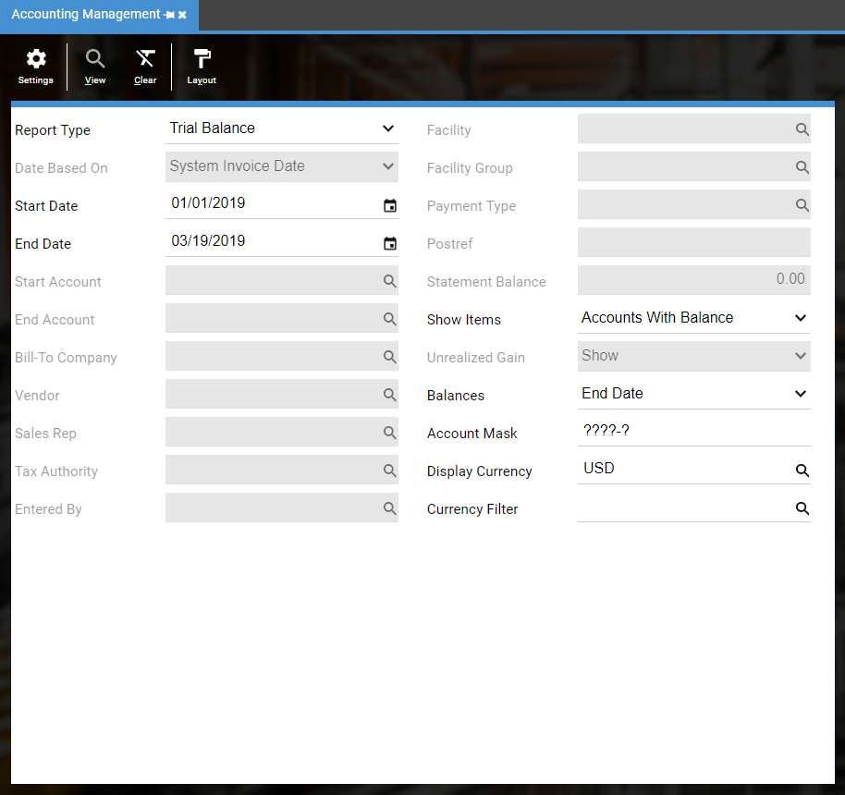

* Filter by AR Account if you have multiple AR accounts

Confirm that AR total balance matches the total Order Summary Balance above

* In DEACOM, go to **Accounting > Accounting Reporting**
* **Report Type**: Receivables summary – Bill To
* **Date Range**: Use default date
* If applicable, run reports by facility, using the Account mask
  + (e.g. ??????-01-??-?? where the second segment is the facility.)
* Click on **View**

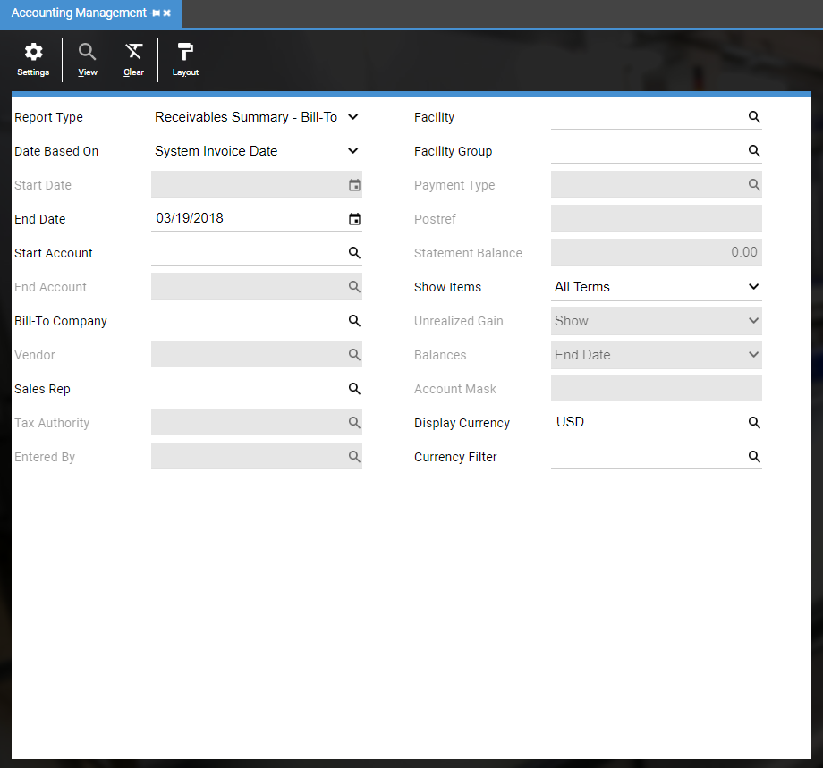

* **Note**:XX SO Payment profile must be run in order for this to report correctly

Confirm that total Receivables summary Total Due matches the total balances above

* Prior to Actual Go Live, test daily processes using imported data. This typically occurs after a Mock Go Live and/or during a Conference Room Pilot (CRP).

Receive payments on imported accounts receivable

## How

The best way to begin is bring up the sales order in the legacy system and bring up the sales order in DEACOM. Compare all key fields including Due to Ship date, which is required for MRP, to confirm they match what was imported. Be on the lookout for any missing data. If multiple facilities are imported, run facility reports and confirm the facility is properly set. If using multiple currency, check that the currency is set correctly. Don’t forget to check Sales Assignments and Tax Regions if applicable.

## Roles & Responsibilities

Typically, Subject Matter Experts, Customer Service and/or Sales employees have the responsibility to validate the data. The Accounting team should confirm the proper AR accounts are being used as invoices with an open balance must match the trial balance.

# Data Validation – Full Circle

Below is the full circle for validation.

## Data Imported

Data is imported and validated by the Data Specialists and/or Product Specialist. This validation is a comparison to the load files provided and to confirm the data is going into the correct fields.

## Data Validated

Once imported, it is important for data to be validated by the Subject Matter Experts and/or End Users. This validation is a comparison to the legacy system. Data specialists do not know what is missing if the file never contained the information.

## Data Processed

Once the data is validated, it is time to use the imported data by doing transactions in DEACOM. This ensures the imported data will transact properly with customer specific data. This builds the End Users’ confidence and confidence in DEACOM is higher.

## Postings

Once the data is used in transactions, it is imperative that the general ledger postings are reviewed. That will ensure the configuration of the items, customers, and facilities are posting the dollars to the correct accounts.

## Reports

Once all of the above is completed, run the reports needed to run your business. Are the proper results being captured? All necessary reports should be created and validated before Go Live.

# Why Data Validation Is Critical

When the data has been validated…

## Lower Risks

It has been proven to reduce the risks at Go Live. Less unforeseen issues arise if the data processes have been validated. Practicing with the validated data ensures daily transactions will be able to be completed and lowers overall risks.

## Go Live Duration

It has been proven to reduce the amount of time required for the actual Go Live. If historical data is imported and validated before Go Live, it reduces what needs to be validated during the Go Live. If doing several phases, it will reduce the amount of time Production systems need to be down.

## Customer Service

It will ensure customers will receive accurate orders and invoices. Customer payments can be applied to the correct orders.

## Procurement

It will ensure vendors continue to receive accurate orders and send the material needed for Production. Payments will be sent to the correct Remit to.

## Reporting

Accurate reporting is the result of validation, whether validating imported data or validating manually entered orders. Data that is accurate and usable is crucial to every company to make informed decisions.

## Success

Validated data is the first step to a successful Go Live. The more accurate the data, the quicker the road to success.